**Experiment 5**

**Student Name:**Rajiv Paul **UID:**20BCS1812

**Branch:** CSE **Section/Group:** 702 A

**Semester:** 5th **Date of Performance:** 15/09/2022

**Subject Name:** DAA Lab **Subject Code:** 20-CSP-312

**1. Aim/Overview of the practical:**

Code and analyze to find an optimal solution to matrix chain multiplication

using dynamic programming.

**2. Task to be done/ Which logistics used:**

To write code and analyze to find an optimal solution to matrix chain multiplication

using dynamic programming.

**3. Algorithm/Flowchart (For programming based labs):**

**4. Steps for experiment/practical/Code:**

package com.DAA;

public class DAA_exp5 {

static int MatrixChainOrder(int p[], int n)

{

int m[][] = new int[n][n];

int i, j, k, L, q;

for (i = 1; i < n; i++)

m[i][i] = 0;

for (L = 2; L < n; L++) {

for (i = 1; i < n - L + 1; i++) {

j = i + L - 1;

if (j == n)

continue;

m[i][j] = Integer.*MAX_VALUE*;

for (k = i; k <= j - 1; k++) {

q = m[i][k] + m[k + 1][j] + p[i - 1] * p[k] * p[j];

if (q < m[i][j])

m[i][j] = q;

}

}

}

return m[1][n - 1];

}

public static void main(String args[])

{

int arr[] = new int[] { 1, 2, 3, 4 };

int size = arr.length;

System.*out*.println();

System.*out*.println("Minimum number of multiplications is "

+ *MatrixChainOrder*(arr, size));

}

}

**5. Observations/Discussions/ Complexity Analysis:**

Time complexity is O(1).

**6. Result/Output/Writing Summary:**

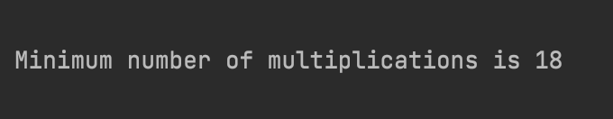

**Learning outcomes (What I have learnt):**

**1. Learnt about dynamic programming.**

**2. Learnt how to make optimal algorithm.**

**3. Learnt about matrix application using dynamic programming.**

**4. Learnt about the implementation of dynamic programming.**

**5.**

**Evaluation Grid (To be created as per the SOP and Assessment guidelines by the faculty):**

|  |  |  |  |
| --- | --- | --- | --- |
| Sr. No. | Parameters | Marks Obtained | Maximum Marks |
| 1. |  |  |  |
| 2. |  |  |  |
| 3. |  |  |  |
|  |  |  |  |